PART CATALOGUE-CUM-SERVICE MANUAL OF HYDRAULIC REVERSIBLE MOULD BOARD PLOUGH
  - Quality Raw Material
  - Advance Technology
  - Under Expert Supervision
  - Prompt Service After Sale
  - Most Reasonable Price
Bhansali Agri. Implements Pvt. Ltd.
Kopargaon, 423601, Dist: Ahmednagar, Maharashtra (India)
Tel: 91-2423-223394
Web site: - www. bhansaliagri.com
Mail Id: - bhansaliudyog@gmail.com

CONTENT
Sr. No. | Particulars | Page no.
 | Preface | 3
 | Know your machine | 4
 | Instruction | 7
 | Safety signs | 9
 | Preparation of tractor | 11
 | Attachment of the MB Plough to Tractor | 12
 | Detachment of the MB Plough from Tractor | 14
 | Operating of implement | 15
 | Adjustment | 18
 | Assembly | 20
 | Maintenance, servicing and repairs | 22
 | Trouble shooting | 26
 | Warranty | 28
 | Part catalogue | 31

PREFACE
Forwarded Congratulation!
Dear Customer,
Congratulation on owning BAHUBALI MB Plough, a special offering from BAHUBALI, your trusted friend in farming. You will find this MB Plough to be the best in its class among all the MB ploughs available in the market.
The MB Plough has been specially designed by considering the conditions of your field and its needs. Its dimensions are designed to make it suitable for all field conditions. We sincerely hope that this association would be just a start and we would be given an opportunity to serve you with many more products that would help you increase productivity and yield.
Message to our customers
We are pleased to provide you with this MB Plough, a booklet containing the safety, operating instructions, service information prepared by our experts. Kindly go through this manual to operate MB Plough safely. Also we are obliged to provide you technical assistance. You would be at peace owning and operating the MB Plough.
Customer responsibilities
It is the Customer or Operator’s responsibility to read the Operator’s Manual, to operate, lubricate, maintain and store the product in accordance with all instructions and safety procedures. Failure of the operator to read the Operator’s Manual is misuse of this equipment. Machine must be kept in a place protected from heat, damp, and corrosive agent.
Customer or Operator should take responsibility to inspect the product and to have any parts repaired or replaced when continued operation would cause damage or excessive wear to other parts or cause safety hazards. It is the Customer’s responsibility to deliver the product to Authorized Dealer, from whom they purchased it, for service or replacement of defective parts which are covered by warranty. Repairs to be submitted for warranty consideration must be made within thirty days (30) of failure. Wishing you a wonderful season ahead.

With warm regards,

Team BAHUBALI

KNOW YOUR MACHINE
Features
- Reversible MB plough is used for breaking & inversion of the hard soil where other implements cannot penetrate.
- It has a pair of 2 and 3 sets of MB ploughs which can be changed or revered to work in both directions.
- Reversing of the furrow easily done by hydraulic actuation mechanism.
- Since two furrows are used it reduces ploughing time.
- It performs the function of deep opening and loosing of soil.
- It lifts the soil-clod and throws it on the soil surface breaking the soil-clod into smaller particle size.
- Easy to attach to the tractor hydraulic control valve & easy to mount on tractor three-point hitch system.

Technical specification:
Description | 2 Bottom |  | 2 Bottom | 3 Bottom
Model | 2FRPH-45 |  | 2FRPH-50P | 3F2FRPH-60RP60
Number Of Furrow (One Side) | 2 Bottom |  |  | 3 Bottom
Size of Board/MB, inch | 12,14 |  | 14,16
Complete width of Cut in inch | 24-28 |  |  | 28-32
Depth of Cut, Inch | 10-12
Size of leg, mm | 40
Material of Shear Bar & land slide | EN 45
Overall L x W x H, mm | 1750 x 940 x 1230 | 1750 x 1110 x 1285 |  | 2030 x 1220 x 1270
Material of Shear Point | EN 8
Actuation of change of Board/MB | Hydraulic
Weight (Approx.) in Kgs | 350 |  | 370 | 520
Suitable HP Range | 45 – 55 |  | 55-60 | 60-70
Load ability ( Rapping/wooden create), Nos. | 48/42 |  | 48/42 | 40/40

Identification view
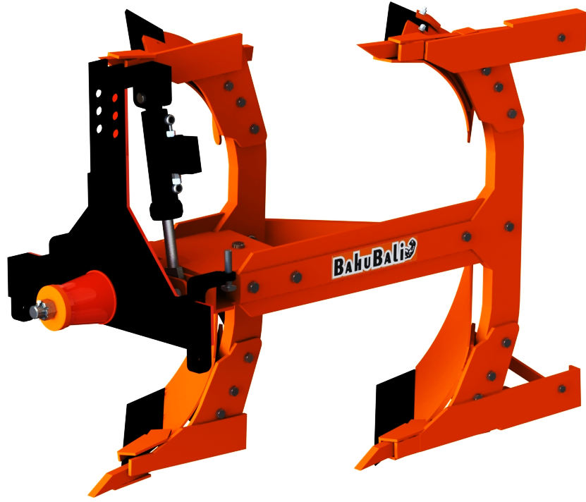
1. Three point linkage of casting
2. Hydraulic to turn furrow
3. Frame
4. Shear blade
5. Shear bar
6. Mould plough

6
5
4
3
2
1

INSTRUCTIONS

- Read carefully this operation manual to work safely. Make sure the operator knows how to operate the machine. The operator's manual is a good source of information and should be reviewed thoroughly. The instruction manual must be kept safe as long as the machine lasts.
- The safety information given in this manual does not replace any safety Codes, insurance needs, federal, state and local laws. Make sure your Machine has the correct equipment required by your local laws and regulations.
- This safety alert symbol indicates important safety messages in this manual. When you see this symbol, carefully read the message that follows and be alert to the possibility of personal injury or death. Keep all safety decals clean, replace illegible or damaged decals promptly.
- And understand all the caution, warning and danger. Make sure you check all controls in all safe area before starting.
- Wear close fitting clothes and appropriate safety equipment while maintenance/servicing.
- Do not allow to stand or sit on the implement/Beware of bystanders/ children’s to prevent serious injury or death while any operations or transporting. Riders could slip off and fall under the implement resulting in serious injury or death.
- Never put any body parts on cutting, moving/rotating, heating parts if at all possible. To avoid injuries guards and safety shields need properly fitted before you go for operation. Certain types of farm machinery cannot be completely guarded due to the nature of their work. Keep a safe distance from all cutting or moving parts.
- Before any operation, disengage power, lower implement, shut off the engine and remove the key.
- Always clean and check the adjustments, nuts and bolts before operation. Tighten nuts and bolts for appropriate torque.
- Maintain the forward speed at the time of operations, turning, crossing slopes, and on rough, slick or muddy surfaces. Where possible, avoid operation near ditches, embankments and holes. Be alert for holes in terrain and other hidden hazards and also always drive slowly over rough ground.
- Clean the implements at the time of storage.
- Make sure parking brake/stand is engaged before dismantle/assemble, mounting/dismounting and loading/unloading. Block parking/raised equipment with jack stands or other suitable means.
- Before properly connecting and disconnecting hoses, check leakages periodically and wear safety gloves. To prevent personal injury, relieve all pressure before disconnecting fluid lines.
- Properly attach three point linkage as per instruction manual.
- Lubricate greasing point with SAE 10W oil at hourly interval.
- During operation if abnormal noise occurs, stop the tractor immediately and determine whether the implement has hit an obstruction.
- Continuous usage of the machine can cause secondary effect, overheat the reduction unit and parts of the hydraulic circuit. Never touch these parts immediately after use as they are very hot and can cause burns. Take a break while operation to work more effectively.
- The spare parts must correspond to the requirements established by the manufacture.
- Check all levers are in neutral position before operation.
- In case of any damage try to visit at service centre or contact dealer, do not open or repair the implement unless trained person.

SAFETY SIGNS
Description | Symbol
Caution - Read Operator Manual  - Read operator’s manual before operating, servicing or repairing equipment’s follow all safety rules and instructions.  - It is the implement owner’s responsibility to instruct and have a person to read the implement operator’s manual to learn how to operate your implement safely. Failure to do so could result in serious injury or death and equipment damage. | 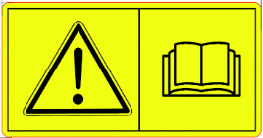
Warning - Crush Hazards  - Beware bystander or operator to serious injury or crushing hazards at the time of dismantling/assemble, servicing or repairing.  - Make sure parking brake/stand is engaged before loading and unloading attaching/detaching, dismantle /assemble and other any operation.  - Do not allow to stand or sit on the implement to prevent serious injury or death while operating or transporting. |   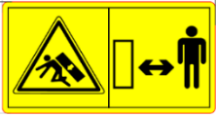  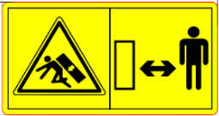
Warning - Crush Hazards  Before servicing/ maintenance, making adjustments, dismantle /assemble, dismounting/mounting the machine. Disengage power, shut off the engine make sure all the revolving parts have stop and remove key. | 
Warning - Crush Hazard  - Hands, feet, fingers and other body parts could be crushed between implements and tractor.  - Operate tractor controls from operator’s seat only.  - Do not stand between implements and tractor when tractor is in gear.  - Make sure parking stand/brake is engaged before going between implements tractor and at the time of any operation.  - Stand clear of the machine when in operation or when it is being raised or lowered. | 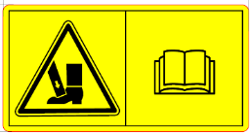  
Warning – Crush / Pinching Hazards  - Wear safety gloves while locking/unlocking, attaching/detaching dismantle /assemble and other any operation like servicing, maintenance of the implements and tractor. | 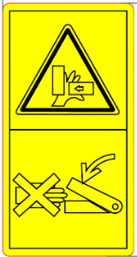
Hydraulic Injections – Refer Operators’ manual  - Refer Operator manual and follow the procedure mentioned in Operator manual before connecting the hydraulic hoses.  - Before properly connecting & disconnecting hoses/applying hydraulic pressure, check leakages periodically, Wear safety gloves and if found please replace the hose.  - Ensure the hydraulic connections are made properly.  - Wear safety gloves while connecting or disconnecting the hoses to safeguard the hands from skin penetration.  - To prevent personal injury, relieve all pressure before disconnecting fluid lines. | 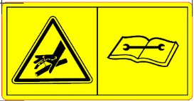

PREPARATION OF TRACTOR
- Always refer to your tractor operator’s manual for specific detailed information.
- Equip your tractor with a ROPS (Roll over Protecting Structure) cab or frame or hood for your protection. See your tractor operator’s manual for correct seat belt usage.
- Tighten the all bolts and nuts, see the bolt tables in the service section.
- Prepare the tractor by carrying out pre-start checks and adjustments in accordance with specifications.
- Use the correct warning signals at all times
- Deal with any hazards and obstacles encountered during operation in accordance with instructions
- Carry out all work in accordance with relevant environmental and health and safety legislation, risk assessment requirements, codes of practice and company policies.
- Before starting the engine of your tractor, make sure all operation controls are in park lock or neutral position.
- Check all tractor system like hydraulic, steering, cooling, fuel etc.
- Properly set tractor DC and PC lever.
- Fuel, Hydraulic oil level transmission oil and lubricating oil should be checked by using dipstick.
- Lubricate to greasing point of tractor.
- If there is need to add front weight for good operation, add appropriate amount of weight on tractor front end as recommended in tractor operator’s manual. Sometimes we need to add counterweight on rare wheels this reduces the Tyre load.
- Match the proper tractor for the implement. The tractor should be properly weighted and able to control the implement, especially when going up or down inclines.

ATTACHMENT OF MB PLOUGH FROM TRACTOR
- MB Plough can be applied to any type of tractor as long as it is supplied with three point universal attachment.
- MB Plough must be positioned on a flat surface, in a stable position and dry area that is free from garbage.
- Make sure tractor engine is off and key is removed before hitching the implement.
- The tractor must reverse towards the MB Plough until its arms correspond with the arms of the three point of MB Plough. During this phase, any pedestrian/onlooker must be at least 5 m away from the machine.
Instructions for attachment of three point linkage
- Lower the PC lever to down the lower links.
- Align left side lower hitch link (E) over the implement left draft link (B), slide the ball over the pin and insert quick lock pin.
- Align right side lower hitch link (D) over the implement right draft link (A), slide the ball over the pin and insert quick Linch pin (I).
- Use the screw jack lever on the right lift arm to align the ball with the pin.
- Remove centre link (C) from the transport hook, lift centre link locking clip and rotate the tab to rear of centre link clip.
- Attach centre link (C) to the top mast (F) by using turn buckle.
- Adjust centre link and lift links as necessary. Lock the centre link with the top link pin and check the implement level on ground.
- Level the frame using the turn buckle.
- In the end check the working height of the implement.
- For attaching the centre link with three-point hitch, the order is the left-right-top or left-top right.
- With the help of PC lever raise and lower the implement check for interference.
- Attach the lower right arm, turn the screw until the mounting pin is at the same level as the hole on the tractor arm. If the gap between the hole and mounting pin is too close or too distant, turn the control arm in or pull it away to an appropriate distance. You may have to adjust both height and distance at the same time. When the hole at tractor arm and mounting pin are even, insert the pin in the hole and lock it with the lynch pin.
- After attaching the implement, lift it and adjust the control arm parallel to the ground. When you look from both rear or sideways, the discs should all be touching the ground uniformly.
Instructions for assembling of hydraulic system
- Connect the cylinder hoses (L) to the tractor selective control valve ports (K)
- Raise the support stand and secure with the lock pin.
- Start tractor engine.
- Slowly move the position control lever to raise the plough. Check that there is no interference. Lower plough to ground and adjust if necessary.

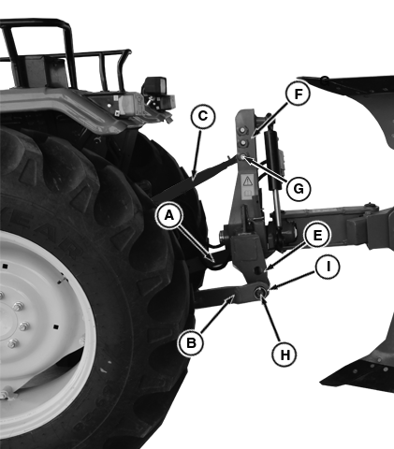
A - Tractor Right side Link
B - Tractor Left side Link
C - Tractor Centre Link
D - Plough Right Lower Hitch Point
E - Plough Left Lower Hitch Point
F – Top mast
G - Mounting Pin
H - Lower Hitch
I - Linch Pin

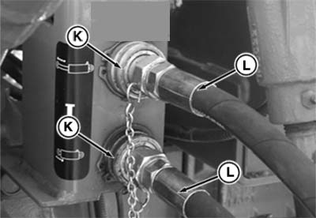
K - Selective Control Valve Ports
L - Hydraulic Hoses

DETACHMENT OF THE MB PLOUGH TO TRACTOR
- Stop the tractor on a flat surface, activate the hand brake.
- Rest the MB Plough on the flat surface in a way that it is stable and horizontal.
- Switch the tractor engine off.
- Disconnect the MB Plough from three point hitch of the tractor, first by taking out the Linch pins from headstock that block the dowels and then by removing the hitch pins from lower link.
- Check that the lower links are fully disconnected from the cross shaft.
- Climb onto the tractor again and move it forward to completely free the tractors arms from the third point of the MB plough.
- Climb onto the tractor again and move it forward to completely free the tractors arms from the third point of the MB plough.
- Release the pressure from the hydraulic hose. See the tractor manufacturer operating instructions
- Disconnect the hydraulic hose pipe with coupling from tractor hydraulic system and electric cables. Fit the protecting caps.

OPERATING OF IMPLEMENT
Warning for the driver
- Before operation check all nuts and bolts of the implement.
- Be vigilant about the tree roots and stones.
- Don’t operate implement on stony soil.
- Tractor should be in first high gear.
- Don’t allow anyone to come across the implement.
- Lift the implement on every turn.
- Lift the implement before approaching the road.
- During use of the implement, the operator must stay on the driver’s position.
- The operator cannot leave the drivers position on the tractor till all working parts of the implement have come to a complete standstill and the three point linkage is disengaged from tractor.
Instructions for driver
- When implement is ready for use don’t stand between implement and the Tractor.
- Properly fit the three point linkage as mentioned above & lock with lynch pin.
- Properly align the mould broad assembly.
- Never turn the tractor to the right or left when the implement is engaged in the soil.
- Never reverse the tractor when the implement is engaged in the soil.
- Always set hydraulic levers correctly for draft and position control operation.
Precautions during transportation:-
- When transporting the implement, shorten up top link to minimum length.
- Set hydraulic levers in top raised position and lock levers.
- Maintain the speed to avoid jumps.
- Watch while overtaking on road.
- Always use SMV (Slow Moving Vehicles) symbols.
Top link
It is used to attach the implement and control its inclination front-to-rear with respect to ground. The distance between its two ball-joints can be increased or decreased by rotating the turn-buckle as follow.
- Loosen the locknut (A)  - Clockwise rotation of turn buckle (B) will decrease the distance.  - Anti-clockwise rotation will increase the distance. Tighten the locknut (A) after desired adjustment.  - Draft sensing bracket transfer the top link force to the draft sensing mechanism. It has three holes A, B and C for hitching the top link and adjusting draft sensitivity is required basis of soil. | 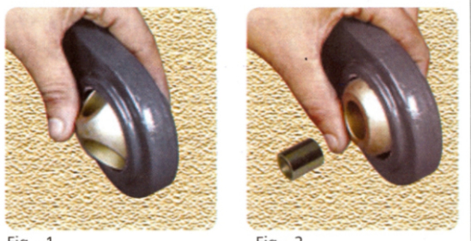  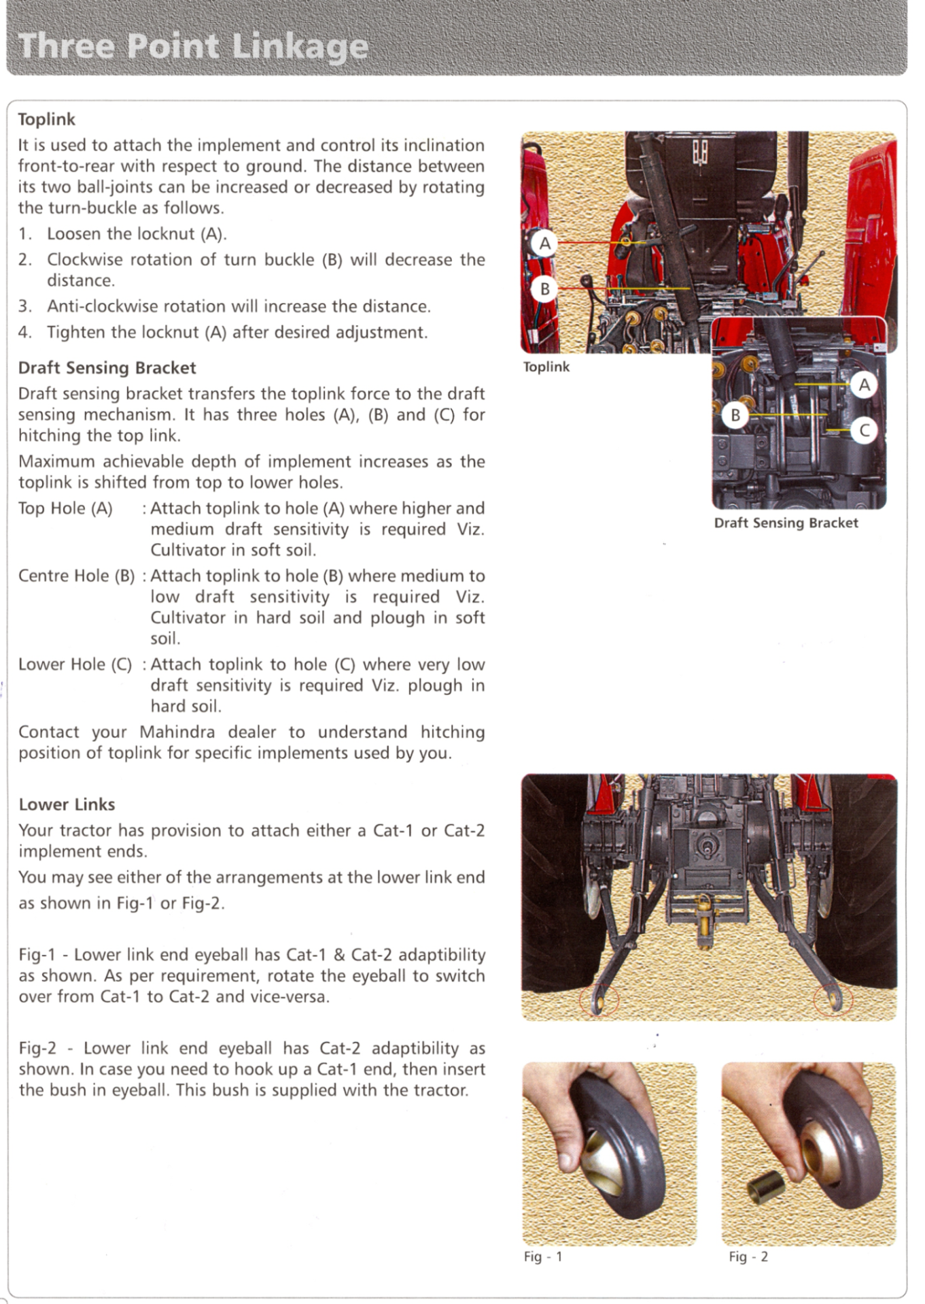
- Lower link end eyeball has Cat-l and Cat-ll adaptability as per requirement
Sensing the draft control
- Move the DC lever (C) to its most forward position.
- Move the position control stop screw (B) to the front of the quadrant and lock it.
- Lift the implement off the by pulling the PC lever (A) back to upper limit.
- Lower the implement into work by moving the PC lever (A) to its most forward position.
- Move tractor slowly in forward gear. When the implement has reached the desired working depth, move draft control lever rearward, until the linkage begins to lift, due to the load on top link, this will be the position of the lever for that particular type of ground.
- Having obtained a desired setting move DC stop screw (D) until it touches the lever DC lever (C) and lock it in this position.
Position control (A)  - Moving the lever forward will lower the implement. Moving the lever rearward will raise the implement | 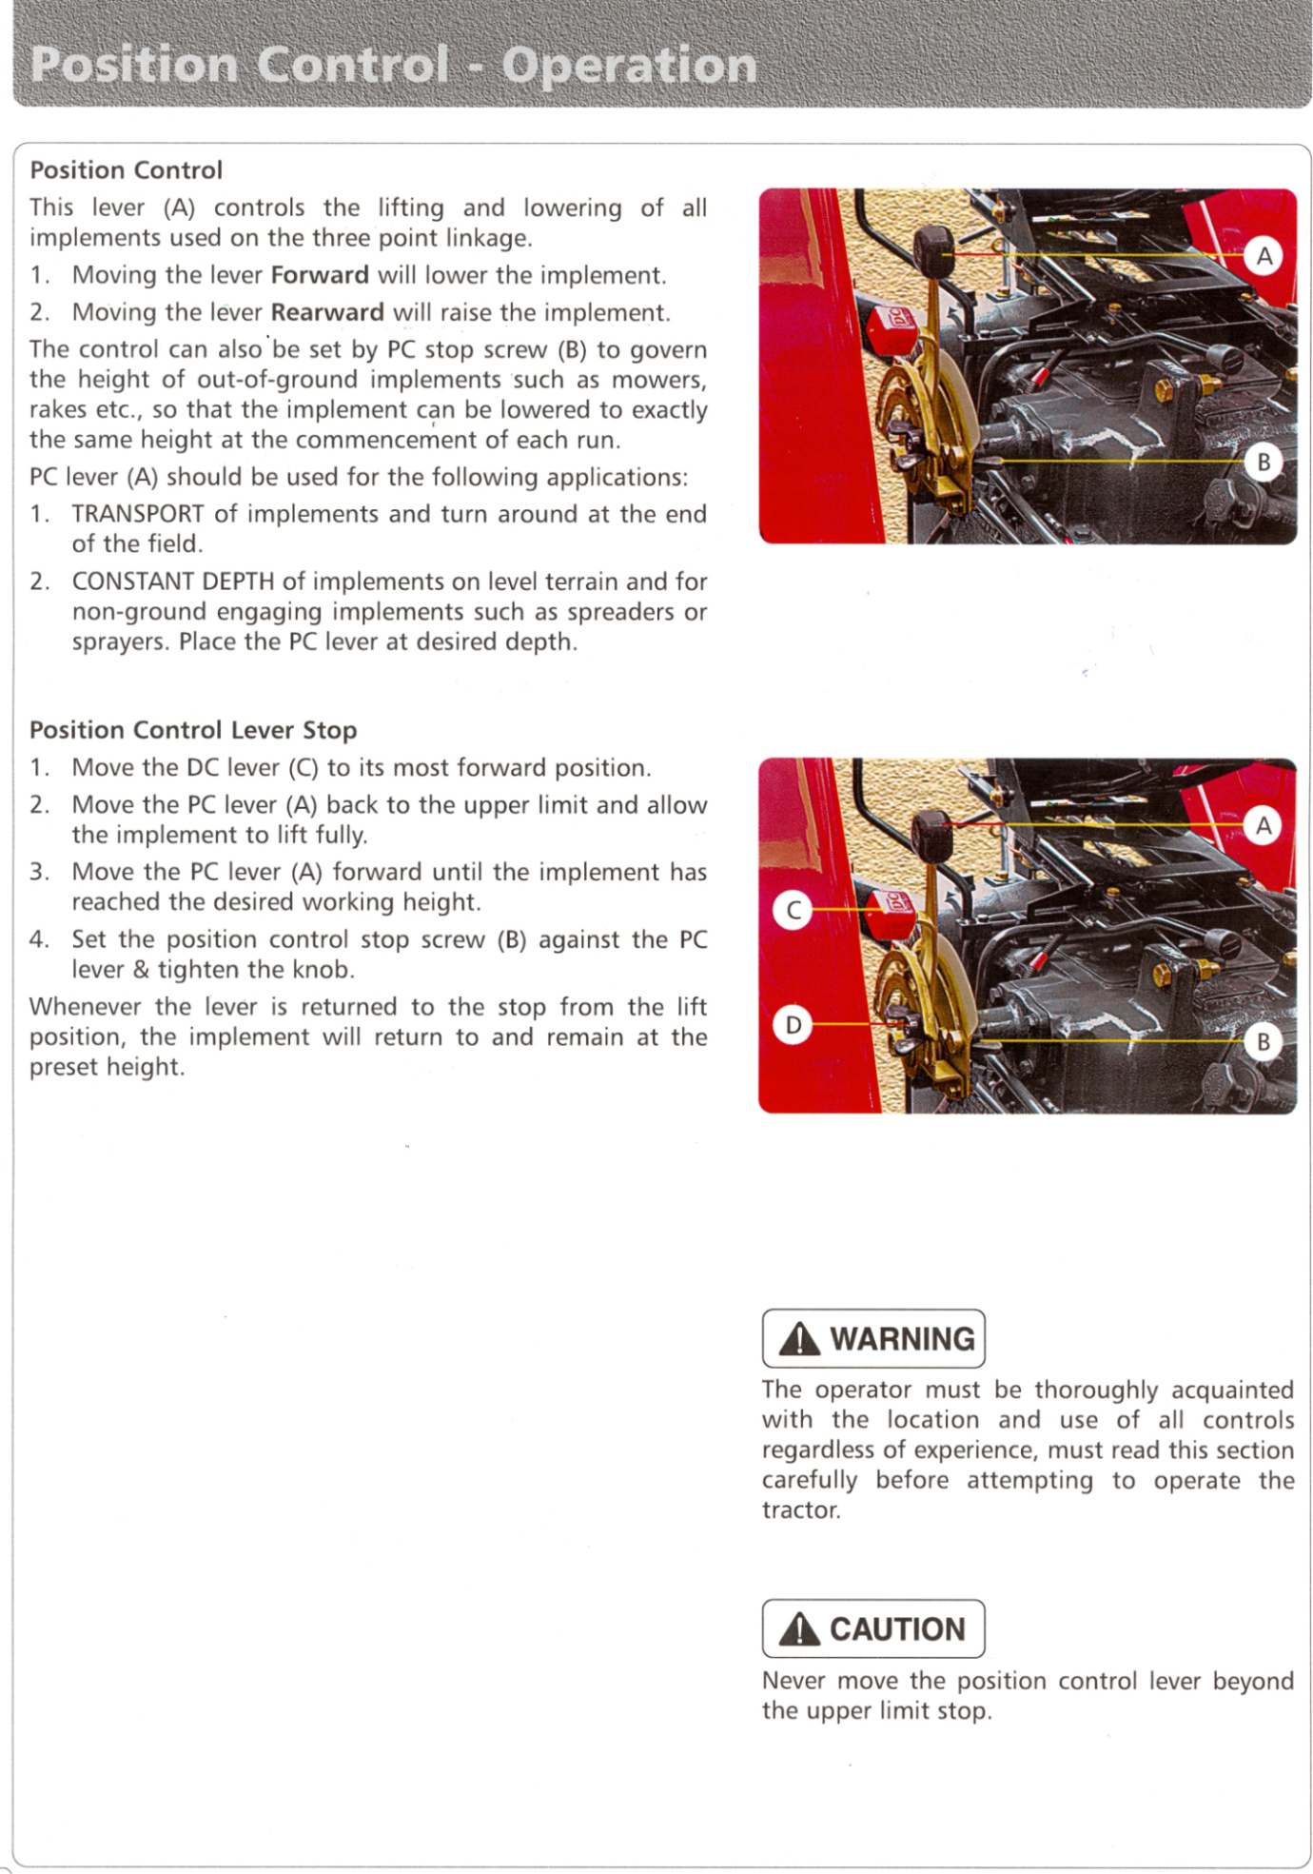
Position control lever stop
- Move the lever (C) to its most forward position.
- Move the PC lever (A) back to the upper limit and allow the implement to lift fully.
- Move the PC lever (A) forward until the implement has reached the desired working height.
- Move the position control stop screw (B) against the PC lever and tighten the knob.
Setting the draft control  - Move the DC lever (C) to its most forward position.  - Move the position control stop screw (B) to the front of the quadrant and lock it.  - Lift the implement off the ground by pulling the PC lever (A) back to upper limit. | 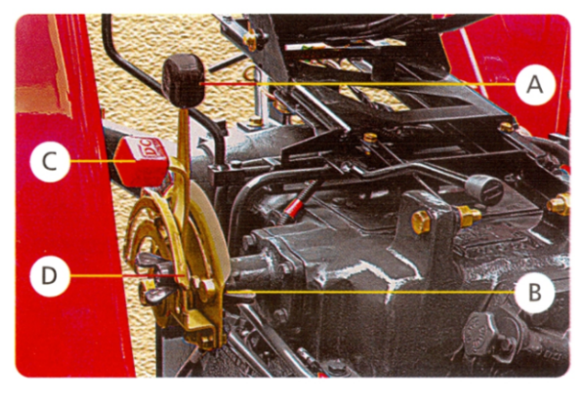
- Lower the implement into work by moving the PC lever (A) to its most forward the quicker the implement will drop.
- Move tractor slowly in forward gear. When the implement has reached the desired working depth, move the draft control lever rearward, until linkage begins to lift, due to the load on top link. This will be the position of the lever for that particular depth in a particular type of ground.
- Having obtained a desired setting move DC stop screw (D) until it touches the DC lever (C) and lock it in this position.

ADJUSTMENT
Before mounting of implement make sure that all nuts and bolts are properly secured. In order to get better results, the following adjustments are necessary.
Adjustments for deeper ploughing:
The depth of the plough can be obtained by the position and draft control levers of the tractor hydraulic system. However more depth can be obtained by:
- Adding extra weight to the plough.
- Reducing the tilt angle. A correctly tilted plough tends to penetrate better.
- If the ground is covered with trash, set the Plough in almost vertical position and add weight to the plough. In such soils notched Plough gives better results.
Alignments of Mould Broad:
Misalignment of a plough bottom may be due to a beam and frog or a combination of the two. Poor alignment results in uneven ridges, poor trash coverage, increased draft and rapid wear of point of share.
Check for horizontal alignment:
The horizontal alignment of a multiple bottom plough may be checked by measuring the corresponding points on any two bottom. The measurements A, B, C and D should not vary more than 12 mm. In a well aligned plough, land side is parallel with the beam.

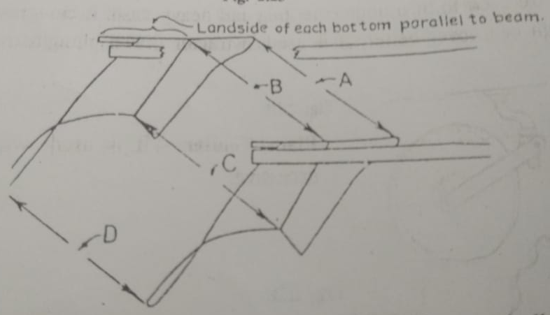
Levelling of plough:
A tractor drawn mounted type Mould broad plough is levelled fore and aft by setting the length of top link. The lateral levelling is done by adjusting the levelling lever provided with one of the lower links of three point linkage system. Shortening the length of top link raises the rear of the plough while lengthening it allows the rear bottom of the plough to run deeper.

Horizontal suction:
It is the amount of share bent out of line with landside. The object of this suction is to make the plough take proper amount of furrow width.
Vertical suction:
It is the bent downward of the point of share to make the plough penetrate the soil to the proper depth when plough is pulled forward.

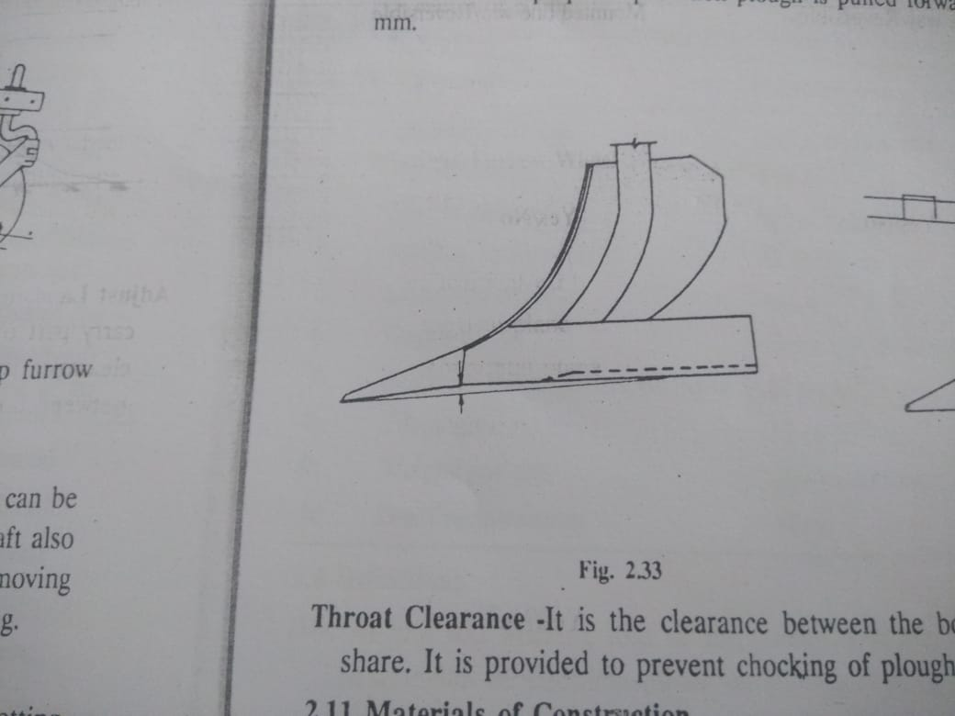
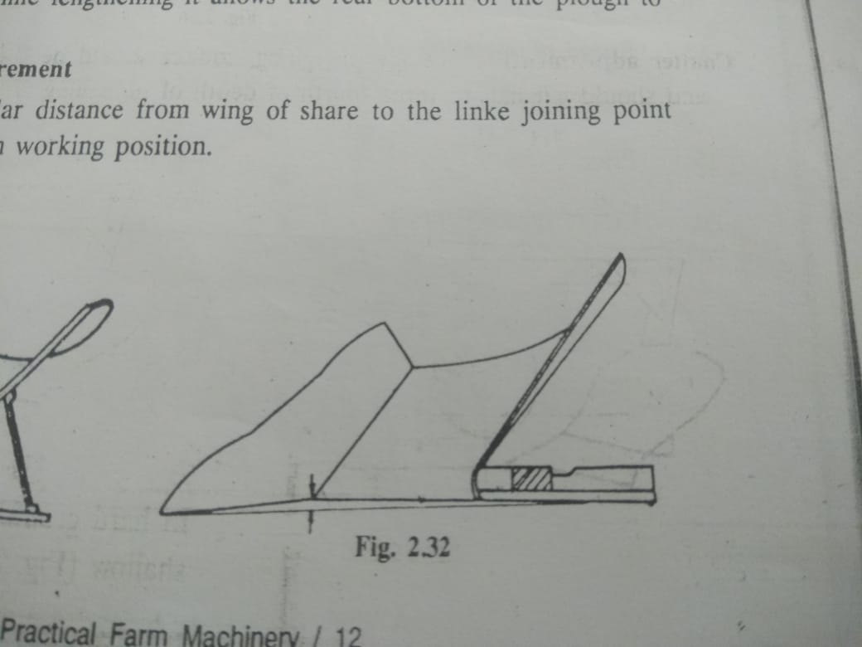
Horizontal suction
Vertical suction

ASSEMBLY
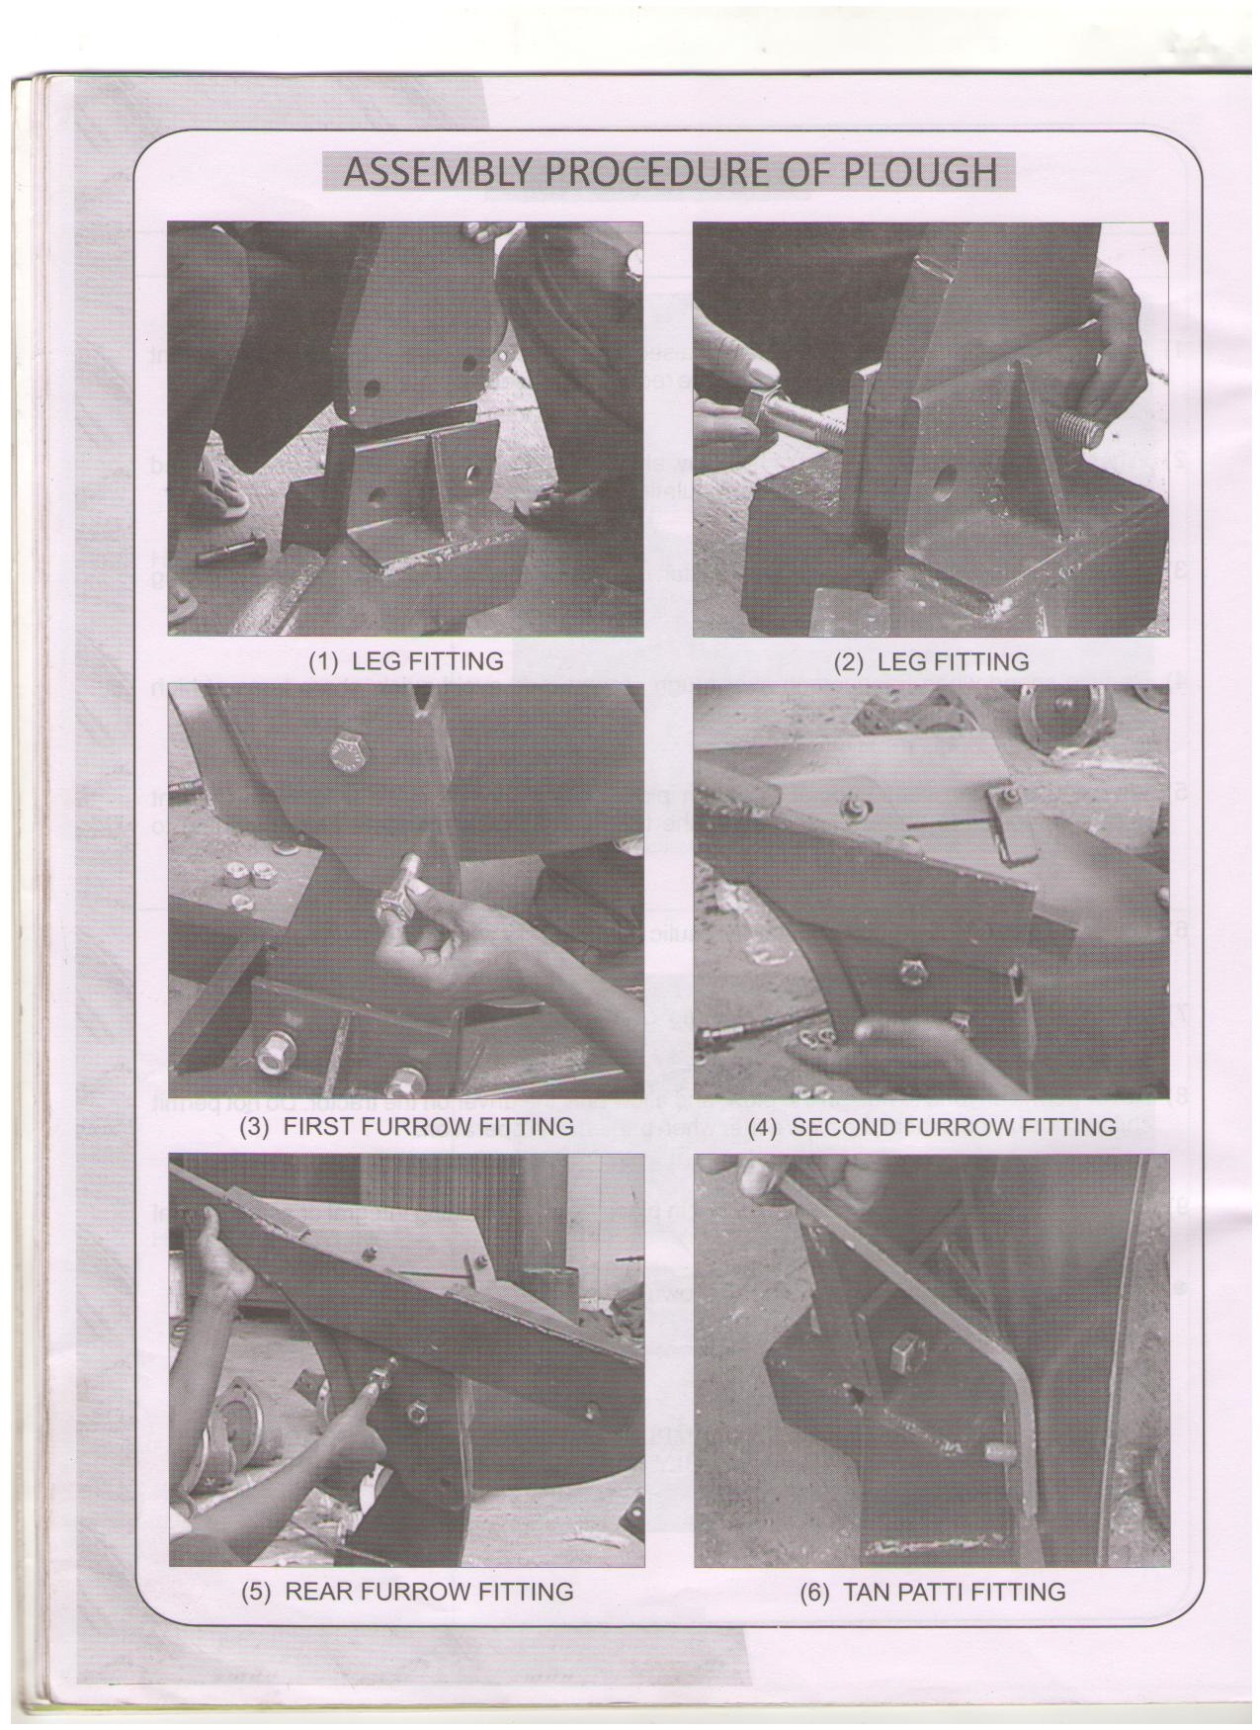  - First furrow fitting | - Second furrow fitting
- Rear furrow fitting | - Tan patti fitting
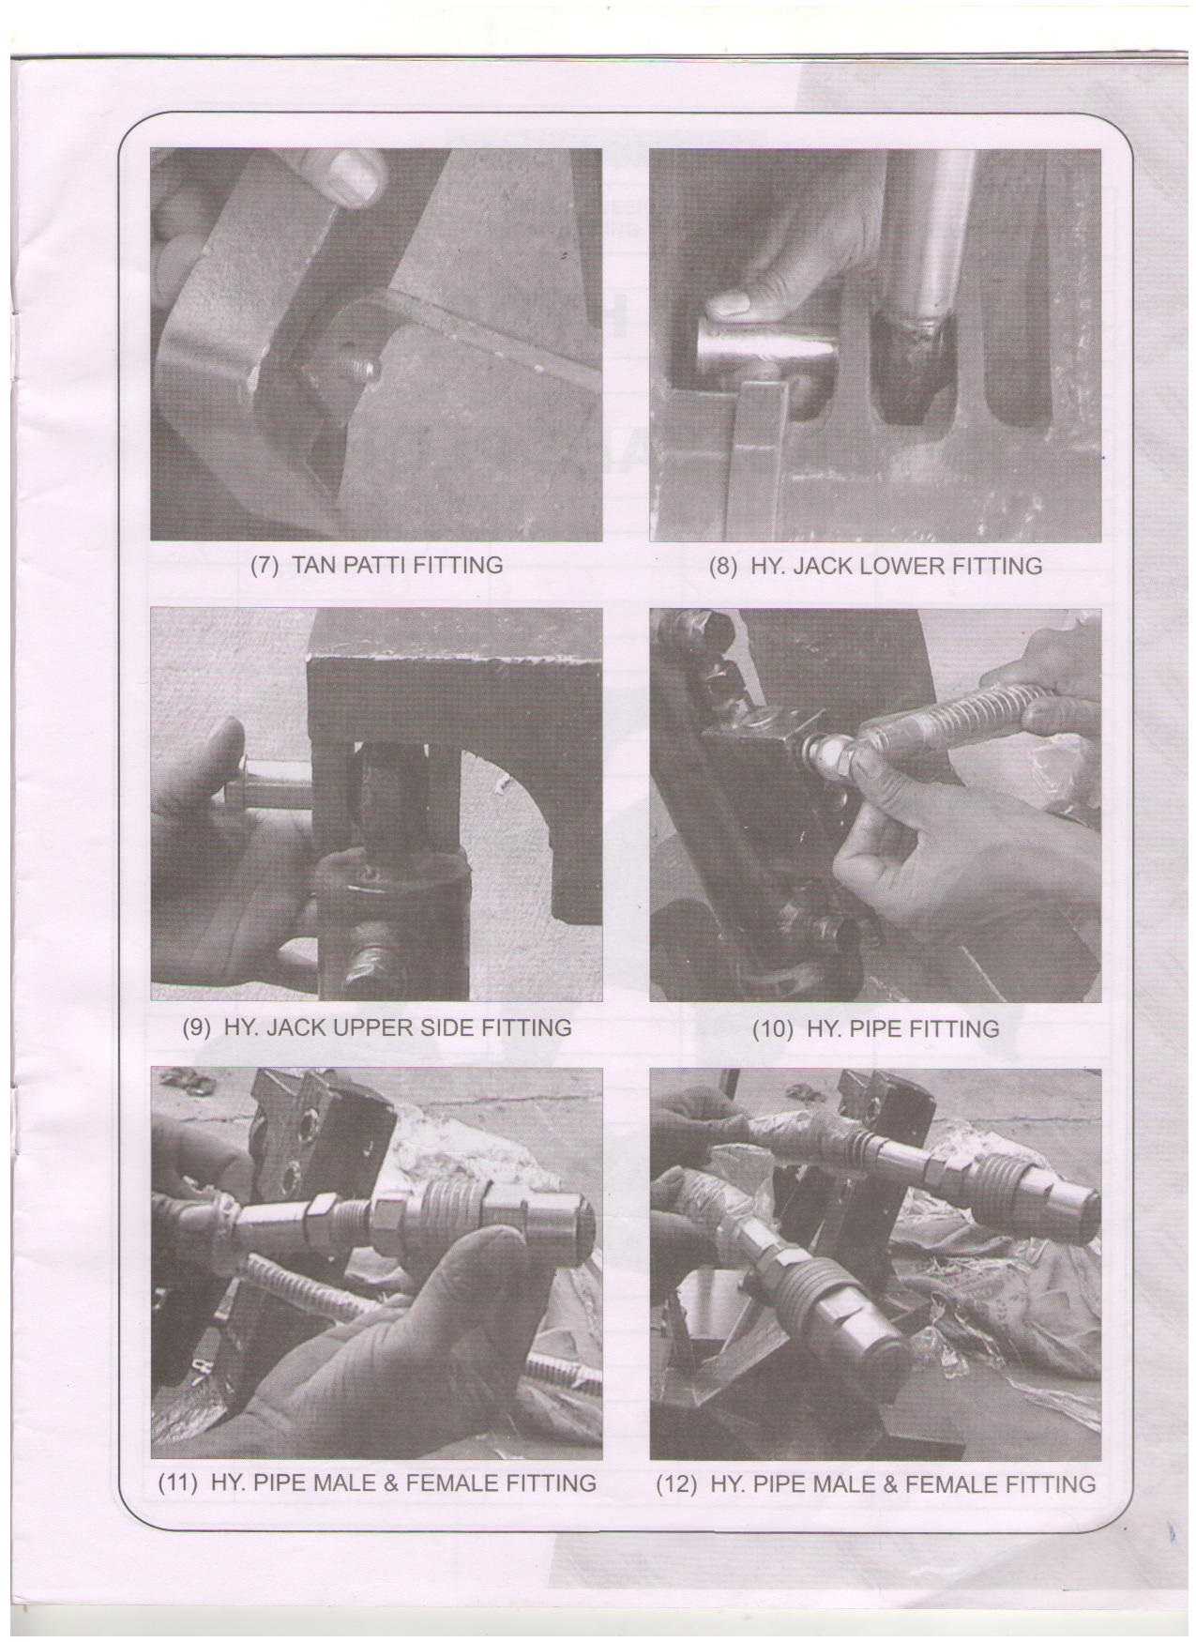  - Tan patti fitting | - Hydraulic jack lower side fitting
- Hydraulic jack lower side fitting | - Hydraulic pipe fitting
- Hydraulic pipe male and female fitting | - Hydraulic pipe male and female fitting

MAINTENANCE, SERVICING AND REPAIRS
- Before servicing the unit and performing maintenance stop the tractor on flat surface, lower the implement to the ground, set the parking brake, disengage the three point linkage, shut off the tractor engine and remove the ignition key.
- Lubrication should be carried out on a daily basis or every 8 hours under normal operating conditions, and more often under extreme conditions for increase life.
- The maintenance/repair work should be carried out at well-equipped workshop or by consulting the dealer/area sales office.
- Any maintenance/repairs/replacement of component or assembly must be carried out or made by a trained person only. It is always recommended to use genuine spares.
Maintenance instructions
If you work the implement on stony land then maintenance also increases. Please follow these rules to get the best results.
- Check the implement adjustments if the steering is hard.
- If implement is new after initial working of first two hours, tighten all nuts & bolts.
- After every fifty hours, tighten all nuts & bolts.
- Check the plough adjustments if the steering is hard.
- Constantly check for loose nuts and bolts.
- Sharpen the Bar Point and Blades if the blades are dull. Blunt blades increase the draft considerably.
Storage of machine after work
- Wash the implement after work.
- Replace the worn out nuts & bolts.
- If implement has to remain unused for long time then clean it & apply a layer of used oil for rust prevention.
- These steps will enhance the life of your implement.
Lubrication
- Please take care that the hydraulic oil quality grease is used in the greasing points.

Servicing interval to avoid damage:
Sr. No. | ITEM | SERVICE | SERVICE INTERVAL
1 | Nut Bolt | Check proper tighten | Daily/100 hrs and less than 300 hrs
2 | 3 Point Linkage | Check proper tighten | Daily/100 hrs and less than 300 hrs
3 | MB Assembly | To check proper attachment | Daily/100 hrs and less than 300 hrs
4 | Share and share bar | To take precaution to safe working load | Daily/100 hrs and less than 300 hrs
5 | Gunnel bolt | Check proper tighten | Daily/100 hrs and less than 300 hrs
6 | Hydraulic system oil level | Check | Daily 10 hrs
7 | Hydraulic system oil/filter | Replace | As specified in tractor operators manual
8 | Safety | Check that the safety equipment is working properly. | Daily checks
9 | Hydraulic lines, hoses connections | Check for leaks, wear,  Replace after 6 year | Daily/10 hrs
10 | Turning Device bearing and ram pivots | Check and lubricate | Every after 50 hrs  Before and after long break
11 | Soil working implement | Check all the soil working implements for damage and wear.  Replace damage or worn component | Daily checks

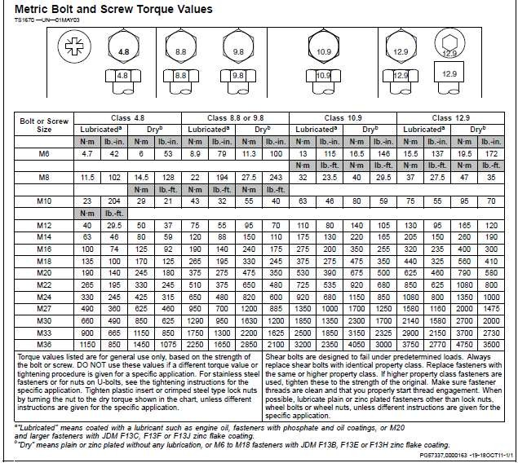
TORQUE CHART

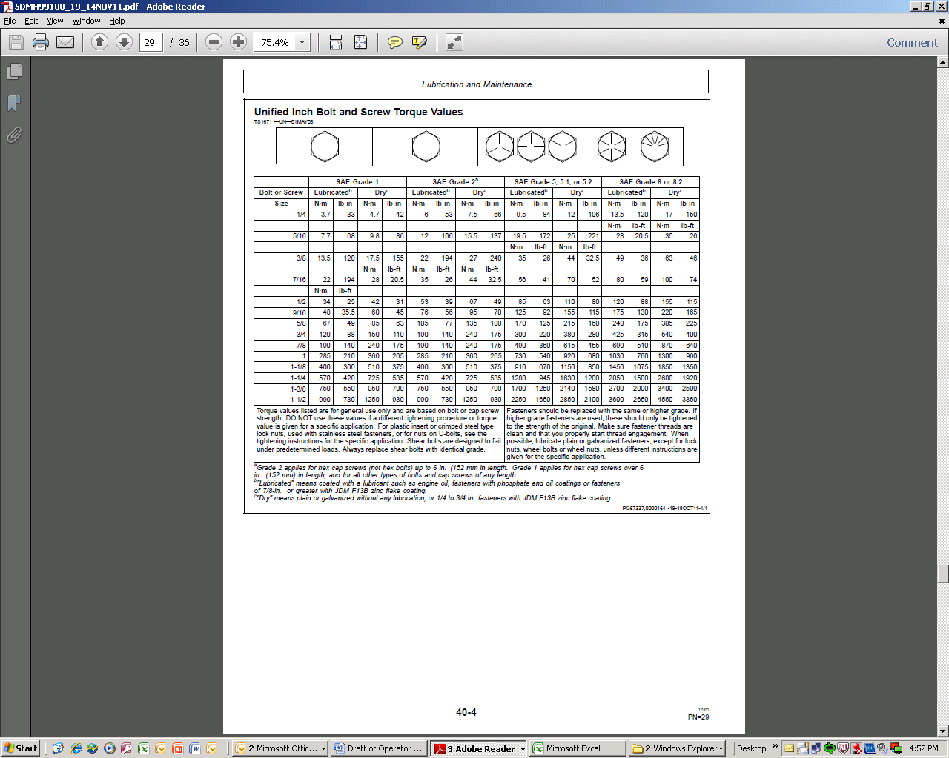

TROUBLE SHOOTING
Sr. No | Problem | Problem Cause | Correction
Hydraulic Equipment
1 | Plough rattles during the first stage of turning | Plough frame is moving ahead, a vacuum is created in the turnover ram | Fit a smaller throttle in the turnover ram connection (T).
2 | The Plough frame turns but the turnover ram switches over before reaching the half-turned position and the plough frame turn back again | 1. The pre-set switch over pressure is too low.  2. The bearings of the turning device are damaged.  3.The inner turnbuckle is too short | 1. Increase the pre-set switchover pressure by fitting additional washer (1 washer = increase 10 bar press) (U).  2. Check the bearings.  Replace the bearings if necessary.  3. Lengthen inner turnbuckle.
3 | The turnover ram switches over immediately without turning the plough | 1. The pre-set switch over pressure is too low.  2. The cone or its seat in the switchover valve is faulty or leaking. | 1. Increase the pre-set switchover pressure by fitting additional washers (U)  2. Replace the turnover ram
4 | Plough frame turns as far as the middle position and stays there | The tractor hydraulic are not reaching the switchover pressure needed for the turnover ram | 1. The pre-set switchover pressure can be reduced by removing the washers (U).  2. Removing one washer/disc equates to a switchover pressure reduction of approx. 10 bar. The washer (U) are located behind the plug (V).  3. Check the tractors hydraulic system.  Maintain the hydraulic system if necessary.
Plough Penetration and Depth Control, Slippage
5 | Plough does not stay in the ground. | 1. Penetration force too low  2. Drawbar is fitted too low | 1. Increase the distance between the point and the frame (not more than 2 cm)  2. Fit drawbar to the upper position.
6 | Plough does not penetrate the soil | 1. Pitch angle of share is too small  2. Top link attached too high on the plough headstock | 1. Retract the body  i.e. Reduce the distance between the point and the frame (not more than 2 cm)  2. Extend the body  i.e. Increase the distance between the point and the frame (not more than 2 cm)
7 | Excessive tractor slippage | 1. Tractor hydraulic system not adjusted correctly  2. Drawbar is fitted too low.  3. Tractor draft control is are not adjusted correctly, weight of the plough is on the depth wheel | 1. Adjust the hydraulic system so that sufficient plough weight is transferred to the tractor.  2. Fit drawbar to the upper position.
Miscellaneous
8 | Shear bolt on the base frequently shears off. | Incorrect shear bolt fitted. | Use an original shear bolt
9 | Implement not work properly & some time lot of vibration happened | Due to improper fastenings | Daily all bolt are properly inspected & properly tight according to suitable torque.
10 | Improper tillage operation. | Improper setting three point linkage | Set three point linkage properly according to operator manual.
11 | Uneven depth operation | Improper tighten and wear  Improper setting three point linkage | Daily all part are properly inspected and replace it  Set three point linkage
12 | Uneven draft during field operation. | Improper setting of draft control | Used suitable hp tractor Proper use of Tractor DC Lever & PC lever.

WARRANTY
We extend warranty for our product against manufacturing defects in materials and workmanship to fulfilment of terms and conditions as below:
- Warranty period is fixed 6 calendar months from the date of commissioning or 12 months from the date of dispatch, whichever is earlier.
- The buyer loses the warranty right if the faults are derived from force majeure, from an incorrect use of the machine or from any wrong action on behalf of the buyer, his employees or third parties repairs, replacements and modifications. Carried out or made to carry out by the without the manufacturing company’s authorizations are included among these actions.
- The warranty is not extended for normal wear and tear of component like rubber components and parts in continuous contact with soil, nut bolt & other brought out items like bearings and oil seal etc., This may form part of our supply and damage occur due to mishandling and accidents.
- Parts manufactured by other companies (leaf spring set, bearings, disk, blades, gears, tyre tube, flap etc.) are warranted by them. For their claim, their decision will be binding for us and you also.
- Any rubber parts, oil seal, nut bolt and electric parts etc. and any part costing below Rs 100 will not be given under warranty.
- Any part which is damaged and is under warranty will not be replaced immediately. A new part has to be buy and damaged part will be send for claimed to the company. If the claimed is passed then handling and transportation charges will be deduced from price and amount will be refunded.
- If there is any technical problem in the implement during warranty period, our mechanic will come and repair it in India. The transportation charges of mechanic should be bearded by you. If there is any major technical problem company experts, engineers will solve it in our factory premises.
- Regular check-up should be done of the Plough and fastener has to be tighten with greasing and loose nut bolt would cause damage to the implement. At that time warranty will not be given.
- The spare parts will always be invoiced on dispatch.
- Warranty is valid only if the equipment is operated and maintained in line with our operating & maintenance manual.
List of warranty parts and Excluded Parts from warranty

Sr. No | Name of parts | Warranty period  (month) | Excluded Parts from warranty
1
2
3
4
5

Letter of Warranty

By Company
To,
Dear Customer,

We always care about your satisfaction. After your complete fulfilments, we have designed mentioned all details about warranty of all parts with period. Kindly read these all terms and conditions before purchasing and signing this bond of warranty. So there will not be any issues after purchasing.
If you are agree with this all terms and conditions, then only sign this bond.
Thank You!

Letter of Warranty

By Customer
To,
Bhansali Agri. Implements Pvt Ltd,

Hereby, I________________________________________________________, from __________________________________________________________________ have read this all terms and conditions mentioned in this warranty book, I am interested to purchase this implement. I found satisfied and agreed with this. So I am signing on this warranty bond.

Thank You!

PART CATALOGUE OF HYDRAULIC REVERSIBLE MB PLOUGH

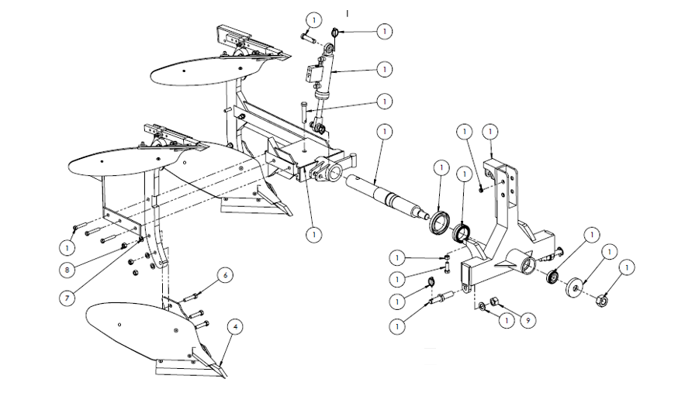

ITEM NO. | DESCRIPTION | PART NO. | QTY.
1 | MAIN FRAME ASSEMBLY - 12'' HRP | P/015101 | 1
2 | TOP BOTTOM - FRONT SIDE - 12'' RP | MHRPB/020 | 1
3 | TOP BOTTOM REAR SIDE - 12'' RP | MHRPB/021 | 1
4 | DOWN BOTTOM - FRONT SIDE - 12'' RP | MHRPB/022 | 1
5 | DOWN BOTTOM REAR SIDE - 12'' RP | MHRPB/023 | 1
6 | BSW Bolt 3-4''X10X3.5'' | RMBOBB/0031 | 12
7 | PLAIN WASHER - 3-4'' | RMBOPW/0007 | 12
8 | BSW Nut 3-4''X10 | RMBOBPN/0007 | 12
9 | BSW Nut - 1'' X 8 | RMBOBPN/0009 | 2

